BEECHWOOD PRIMARY SCHOOL ‘Striving to be the best we can be.’ Meredith Street, Crewe, Cheshire. CW1 2PH www.beechwoodprimary.org Headteacher: Mrs S Harper

Overview for PSHE and SRE
At Beechwood Primary School, we aim to provide learning opportunities through the scheme 1decision. This includes keeping and staying safe, being responsible and learning to deal with feelings and emotions. As part of PSHE children are also taught about preparing for the world of work through learning about money and enterprise.
As part of ‘Sex and Relationship’ education children learn about how to be part of a healthy relationship, staying safe, puberty and conception. This work is carried out age appropriately and in line with statutory requirements. Alongside this scheme we also use a story telling approach to relationship education, the books that are used can be seen below. Parents are invited into school annually to discuss what their children will be covering throughout these lessons.

 | Autumn 1 | Autumn 2 | Spring 1 | Spring 2 | Summer 1 | Summer 2
 | Keeping / Staying Safe | Keeping / Staying Healthy | Relationships | Being responsible | Feelings and Emotions | Our World
Year 1 | Road Safety  Looks at how we can stay safe when crossing the road and travelling in a vehicle. | Washing Hands  Looks at why we should wash our hands and the consequences of not doing so. | Friendship  Looks at how we behave with our friends and how these behaviours can affect others | Water Spillage  Looks at the different ways we can cause accidents and how we can prevent them from happening. | Jealousy  Emphasises the need to recognize our own strengths and those of the people around us, as teaches students to deal with feelings of jealousy. | Growing in our World  Explores the human cycle and how our families are special and unique.
Year 2 | Tying Shoelaces  Looks at how we can prevent accidents that are often caused when rushing around. | Healthy Eating  Looks at how we can make healthy food choices and what might happen if we choose to eat too much healthy food.  Brushing Teeth  Looks at why we should brush our teeth and the consequences of not doing so often enough. | Bullying  Looks at how our actions and words can affect others, and enables students to explore kind and positive behaviours  Body Language  Looks at recognizing how other people maybe feeling and allows students to explore the different ways we can express our emotions. | Practice makes Perfect  Looks at setting goals and developing skills and strategies to achieve those goals.  Helping Someone in Need  Looks at how we can help others at home and in the community and the risks of helping someone we don’t know very well. | Worry  Allows students to identify what they can do and who they can talk to if they feel worried about something.  Anger  Looks at the differences between healthy and unhealthy anger and enables students to identify ways they can manage their anger. | Living in our World  Explores how humans can help take care of living things both inside and outside of the home.
Year 3 | Staying Safe  Looks at the dangers of venturing off with people we don’t know very well.  Leaning out of windows  Looks at the risk of falling from heights and their various dangers we may find in our homes and communities. | Medicine  Looks at why we take medicine and the dangers of taking it without a trusted adult’s permission and supervision. | Touch  Looks at appropriate and inappropriate touch and enables students to explore who they can talk to if they feel uncomfortable in a relationship. | Stealing  Looks at the differences between stealing and borrowing. | Grief  Looks at the different feelings we can experience when we lose someone or something we loved, and enables students to identify ways they can cope when grieving. | Working in our World  Looks at why humans need money and the ways in which money can be used and received.  Looking After our World  Looks at the ways in which we can help look after and protect our planet.
 | Keeping / Staying Safe | Keeping / Staying Healthy | Growing and Changing | Being responsible | Feelings and Emotions | The Working World
Year 4 | Cycle Safety  Looks at distractions on the road and how our actions can cause others harm. | Healthy Living  Looks at how certain types of food can affect our performance in a sports event. | Relationships (Appropriate Touch)  Explores the difficult subject of how relationships can be unhealthy or uncomfortable. | Coming Home on Time  Looks at rules and guidelines children may have to follow. | Jealousy  Looks at how the feeling of jealousy can arise when someone new is introduced to a friendship group. | Chores at Home  Explores the responsibilities that children may have now and in the future.
Year 5 | Peer Pressure  This video looks at how we can be influenced and pressured to make unsafe choices. | Smoking  Explores how someone can be pressured into smoking. | Puberty  Puberty is a short, animated video that looks at the different changes boys and girls go through. | Looking out for Others  Looks at the responsibility we have if we witness someone being bullied. | Anger  Looks at the ways in which we can manage our emotions when we are unable to do something we wanted. | Enterprise  Looks at how children can help pay for items they would like.
Year 6 | Water Safety  Explores the topic of trespassing and the dangers on swimming in open or unknown waters. | Alcohol  Explores the dangers of alcohol and how people can be affected by alcohol in different ways. | Conception  A short, animated video that looks at how a baby is conceived and the various stages  of pregnancy. | Stealing  Explores the topic of taking something from a family member without asking. | Worry  This video looks at transition and the feelings a child can have when staring a new school. | In-App Purchases  Provides a subtle introduction to debt and looks at paying for items through apps or games.

Computer Safety Units of work will be delivered alongside taking part in Safer Internet Day
 | Year 1 | Year 2 | Year 3 | Year 4 | Year 5 | Year 6
Computer Safety | Online Bullying  Looks at being kind and thoughtful online and in real life and allows students to explore what they can do if they feel bullied online. | Image Sharing  Looks at the types of images we shouldn’t share online and how quickly an image can be shared. | Making Friends Online  Looks at the steps we should take to keep ourselves safe and the dangers of meeting someone from the internet in real life.  Computer Safety Documentary  Recaps all of the learning points from the topics and allows students to identify more ways to keep themselves online. | Online Bullying  Looks at the actions we can take if we feel like we are being bullied online. | Image Sharing  Looks at how we can be pressured into sending images and how to manage this. | Making Friends Online  Looks at the dangers of meeting people we have only spoken to online.

There are also optional units to be delivered when appropriate during the year.
 | Year 1 | Year 2 | Year 3 | Year 4 | Year 5 | Year 6
Fire Safety | Hoax Calling  Looks at the risks of making a hoax call to the emergency services and how our actions can affect others. | Petty Arson  Looks at the dangers of playing with lighters and the risk of causing fires | Texting Whilst Driving  Looks at the different types of actions that could distract a driver and how children can influence an adults decision.  Enya and Deedee Visit the Fire Station  Allows students to explore further how they can prevent fires and what they should do if a fire starts in their home.
A World Without Judgement |  |  |  | Breaking Down Barriers  Explores removing barriers and supporting those who have physically disabilities. | Inclusion and Acceptance  Explores the topic of a child having same sex parents | British Values  Looks at how we can be inclusive and insure everyone’s beliefs and needs are respected.

As part of the story telling approach these are some of the books that will be used with children. If you would like to read any of the books please speak to your child’s class teacher.
EYFS
You Choose  Nick Sharratt &  Pippa Goodheart | Red Rockets and Rainbow Jelly  Sue Heap & Nick Sharratt | Blue Chameleon  Emily Gravett | The Family Book  Todd Parr | Mommy, Mama and me  Leslea Newman and  Carol Thompson
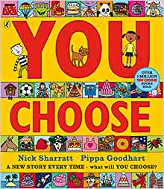 | 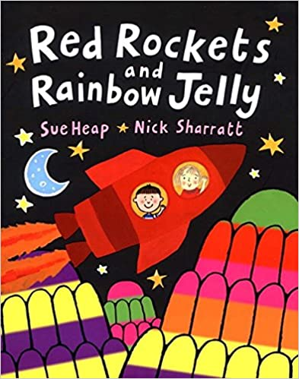 | 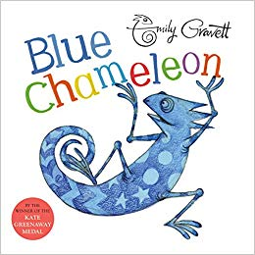 | 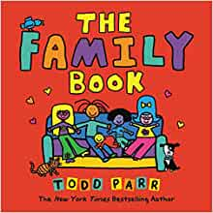 | 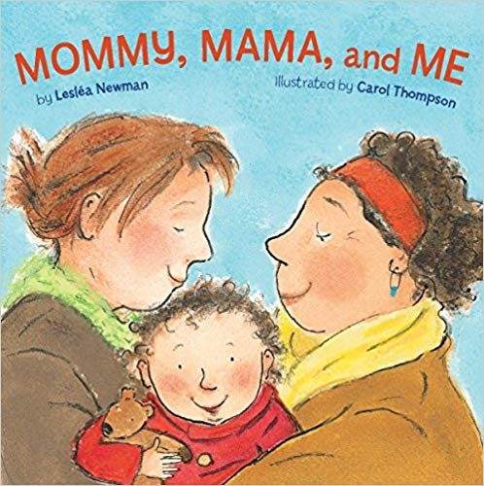
To say what I think. | To understand that it is OK to like different things. | To make friends with someone different. | To understand that all families are different. | To celebrate my family.
YEAR 1
Elmer  David Mckee | Ten Little Pirates  Mike Brownlow and  Simon Rickerty | My Grandpa is Amazing  Nick Butterworth | Max the Champion  Sean Stockdale, Alexandra Strick and Ros Asquith | Mr World, Your World  Melanie Walsh
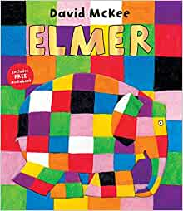 | 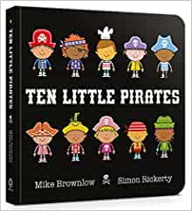 | 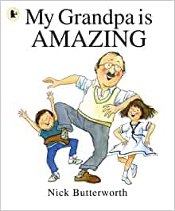 | 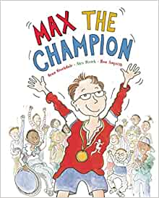 | 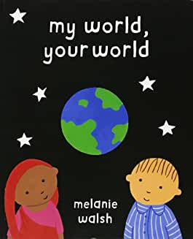
To like the way I am. | To play with boys and girls. | To recognise that people are different ages. | To understand that our bodies work in different ways. | To understand that we share the world with lots of people.
YEAR 2
The Great Big Book of Families  Mary Hoffman and  Ros Asquith | The First Slodge  Jeanne Willis | The Odd Egg  Emily Gravett | Just Because  Rebecca Elliot | Blown Away  Rob Biddulph
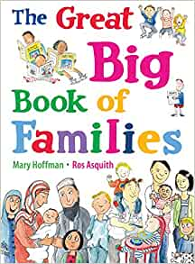 | 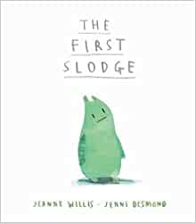 | 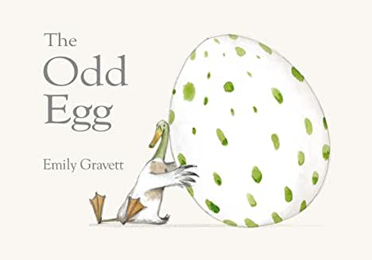 | 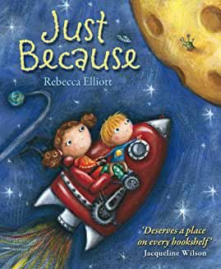 | 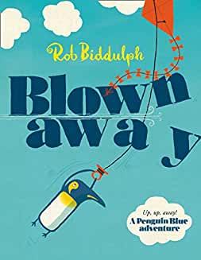
To understand what diversity is. | To understand how we share the world. | To understand what makes someone feel proud. | To feel proud of being different. | To be able to work with everyone in my class.
YEAR 3
Oliver  Birgitta Sif | This is our House  Michael Rosen | Two Monsters  David Mckee | The Hueys in the New Jumper  Oliver Jeffers | Beegu  Alexis Deacon
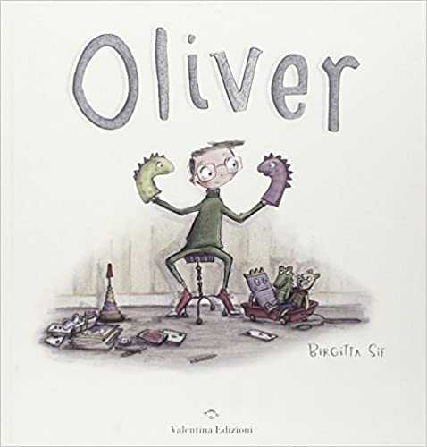 | 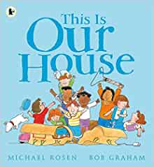 | 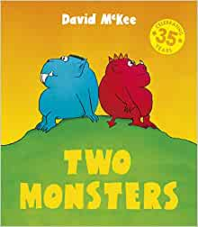 | 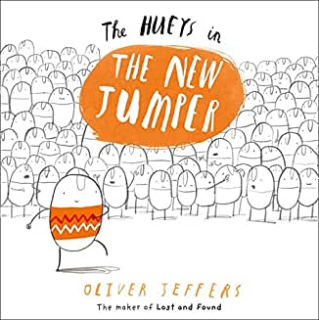 | 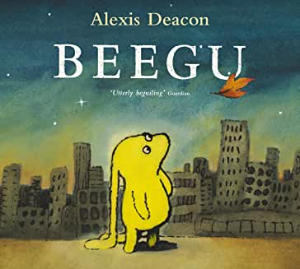
To understand how difference can affect someone. | To understand what ‘discrimination’ means. | To find a solution to a problem. | To use strategies to help someone who feels different. | To be welcoming.
YEAR 4
Dog’s Don’t Do Ballet  Anna Kemp and Sarah Ogilvie | King and King  Linda de Hann and  Stern Nijland | The Way Back Home  Oliver Jeffers | The Flower  John Light | Red: A Crayon’s Story  Michael Hall
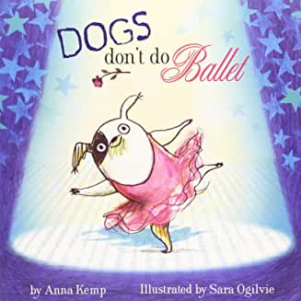 | 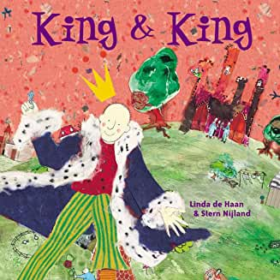 | 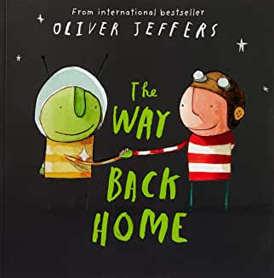 | 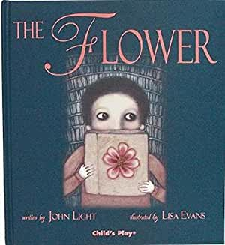 | 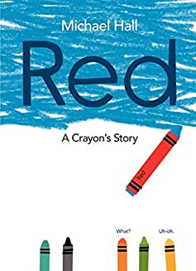
To know when to be assertive. | To understand why people choose to get married. | To overcome language as a barrier. | To ask questions. | To be who you want to be.
YEAR 5
Where the Poppies Now Grow  Hilary Robinson and  Martin Impey | Rose Blanche  Ian McEwan and  Roberto Innocenti | How to Heal a Broken Wing  Bob Graham | The Artist Who Painted a Blue Horse  Eric Carle | And Tango Makes Three  Justin Richardson and  Peter Parnell
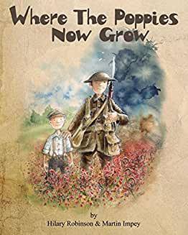 | 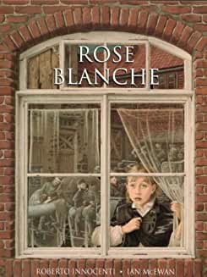 | 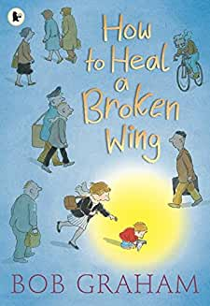 | 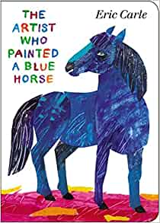 | 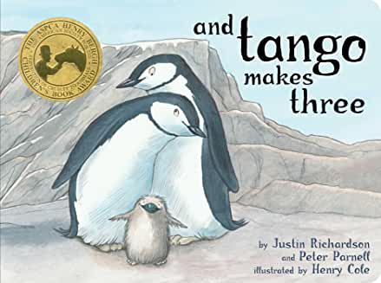
To learn from our past. | To justify my actions. | To recognise when someone needs help. | To appreciate artistic freedom. | To accept people are different from me.
YEAR 6
My Princess Boy  Cheryl Kilodavis and  Suzanne DeSimone | The Whisperer  Nick Butterworth | The Island  Armin Greder | Love You Forever  Robert Munsch | Dreams of Freedom  Amnesty International
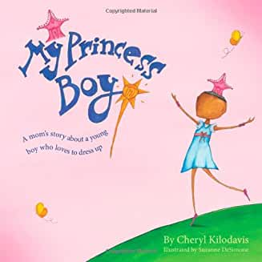 | 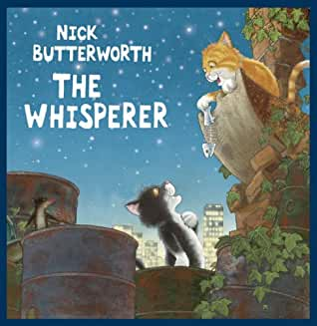 | 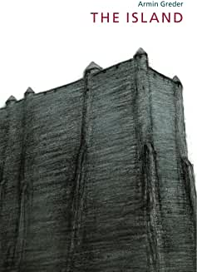 | 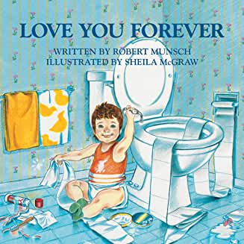 | 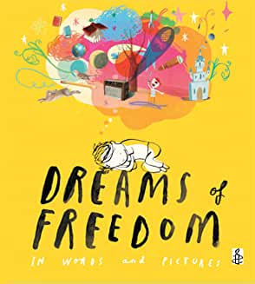
To promote diversity. | To stand up to discrimination. | To challenge the cause of racism. | To consider how my life may change as I grow up. | To recognise my freedom.

