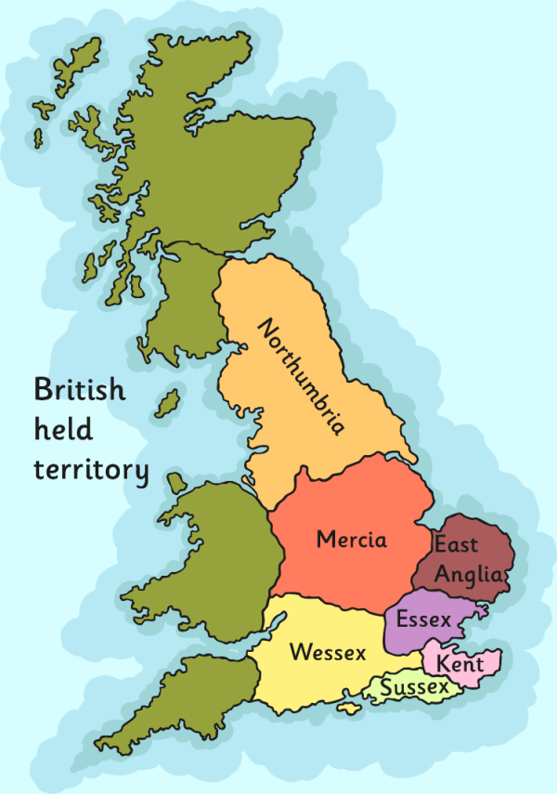

**Key Vocabulary**

**long ship** - a long, narrow warship, powered by both oar and sail with many rowers,

**Settlers**- a person, who settles in an area,

**Viking** - any of the Scandinavian pirates and traders who raided and settled in many parts of North West Europe

**Kingdoms**- A country or state ruled by king or queen

**Monastery**-. A religious house.

**Archer-** A person who shoots with a bow and arrow

**Scandinavian countries** – Norway, Sweden and Denmark

**Dane law**- A treaty made by King Alfred giving Vikings control over some of England.

**Key dates**

AD 787 – The Vikings arrive in Britain

AD 866 - The Vikings capture the city of York.

AD 870 -Wessex is the last Anglo-Saxon kingdom

AD 886 - King Alfred agrees to a treaty with the Vikings. Alfred keeps the west and the Vikings are given the east which is later known as ‘Danelaw’.

AD 954 - The last Viking King of Jorvick (York), Eric Bloodaxe, is forced out of York.

AD 1016- King Ethelred dies.

AD 1066 - The last Anglo-Saxon king, King Harold, is defeated by William the Conqueror at the Battle of Hastings and Norman Britain begins.

**Summary**

* The Vikings first arrived in Britain around AD 787.
* They came to Britain in long ships and their aim was to raid.
* The Vikings originated from Scandinavian countries- Denmark, Sweden and Norway
* They set out in boats called long ships to ‘go Viking’ (which means to go travelling around looking for resources and land to claim as their own).

**Viking Knowledge Organiser**

***The Seven Anglo-Saxon Kingdoms***