Our Town | Task 1 | Task 2 | Task 3 | Task 4 | Task 5
Activity  One | Art  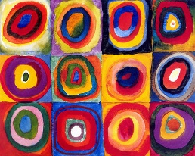  Can you create your own art work based on the artist Wassily Kandinksy? | Science  Can you have a go at planting some seeds? Can you write some instructions about how to plant them?  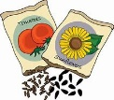  Can you write a diary to show how they have grown? | English  Can you write your own version of ‘Where the Wild Things Are’?  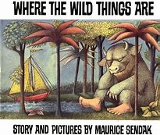 | Geography  Can you create your own birds eye view map of your bedroom at home?  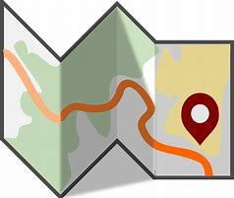  Challenge: can you include a key? | Maths  Can you find half and quarter of different objects? You could use pasta, beads, buttons, sweets or counters.
Activity  Two | English  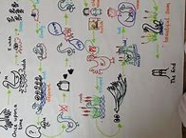  Can you create your own story map for the book ‘Where the Wild Things Are’? | Art  Can you find out some facts about the artist Kandinsky?  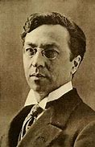 | Geography  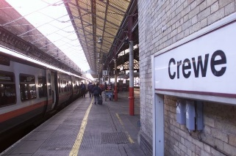  Can you write a list of some of the human features in Crewe? Can you find out any facts about them? | Computing  Can you make your own poster to show how we keep safe on the internet?  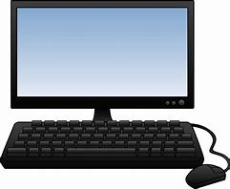 | Handwriting  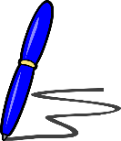  Can you practise your cursive handwriting and the letters of the week this half term?

